10 Most Common Interview Questions
- Tell me about yourself.
Tip: Focus on your professional life and key experiences that qualify you for the position. If you talk about hard times, stay positive and future-oriented!

- Why are you interested in our company?
Tip: Mention specific aspects of the company that attract you, such as its culture, values, or recent projects. Make sure to research beforehand!

- Why are you interested in this position?
Tip: Highlight specific responsibilities or factors from the job description that appeal to you. Use the job posting to guide you!

- What are your strengths?
Tip: Match your strengths with the skills required for the job and provide examples.

- What are your weaknesses?
Tip: Share a weakness that doesn’t affect your core job responsibilities and explain how you’re working to improve it.

- Why did you leave your last job?
Tip: Be honest but keep your answer concise and positive. Never bad-mouth your previous employer!

- How do you prioritize your work?
Tip: Have an example ready of a time-management tool you use.

- Describe how you deal with conflict in the workplace.
Tip: Share a specific example of how you successfully handled a conflict. Keep it blame-free and neutral.

- Where do you see yourself in five years?
Tip: Be realistic and show that you have thought about your future career path.

- What kind of manager do you work best with?
Tip: You should be honest, but you don’t need to take a hard stance.

Interview Rules
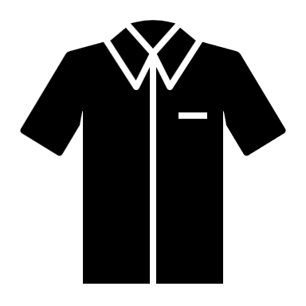
Clothes:




Remember

“What kind of person would I want to hire for my business?”

Presentation:
Good hygiene, show up early, ask questions
Eager to be there, paying attention
Attitude:
Sharply dressed, clean, appropriate
Polite, clean, respectful
Language:

